Good Afternoon shedders,

This is a quick update.

President Norm

As most of you would know Norm and his wife are moving to Cairns to live. Their house is sold and the move will be around 20th- 23rd April.

We are having a **farewell barbecue for Norm** on Thursday 15 April at 12 noon at the Shed. We would like all members to attend to give Norm the recognition he deserves.

We need to know how many are attending so that we can cater for this appropriately.

If you can attend please indicate your intention by putting your name on the list in the Shed or by return email.

Full Day First Aid Course

Next Wednesday, 31 March.

The following members have indicated that they will be attending – Norm, Tony, Leo, Teo, Barbara, Peter R, Gerald, Bill, John R, Peter S, Geoff M, Paul H, Doug and Chris B.

We still have a few vacancies so if you would like to join us please let me know by email. The course is Free to you. We start at 8.30 and go through until approx. 4pm. The course will be held in the Community Centre in the stadium. You will need to provide your own lunch or go and get something at the break. We will provide tea, coffee and bottles of cold water.

Committee meeting

The next committee meeting will be held next week, Thursday, 1 April at 1pm, in the Shed.

The main item of business for this committee meeting is to appoint a President to fill Norm’s position. This appointment will be until this year’s AGM sometime in July when a new President will be voted in for the next 12 months. If you would like to be nominated for the extraordinary vacancy of President please let Norm know so he can put your name forward at this meeting.

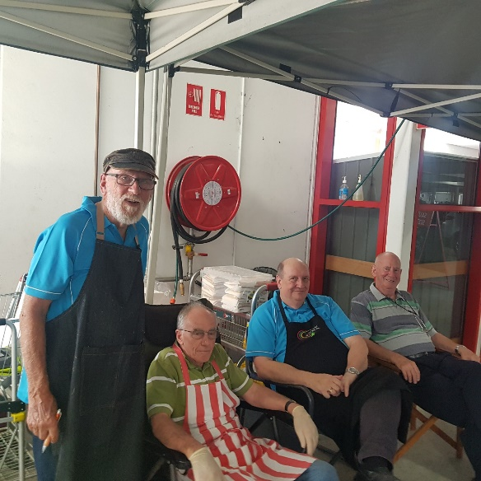Bunnings BBQ

Our latest BBQ was last Saturday. A good social event for those who attended and at the same time we made just over $800 profit for our Shed. A great way to keep your membership fees low. We have booked three more BBQs for the year so that we have one every three months. It is fair to expect each member rosters themselves on for at least one of these times so please give this some serious thought as I would like to think our Shed is one where everybody does their bit and doesn’t leave it to just a few.

CNC Router

As I type this I expect that our new machine is being manufactured and will be sent to us within the next few days. We have purchased this from an Australian manufacturer, Bluecarve, based in Victoria.