February Update

Welcome Back

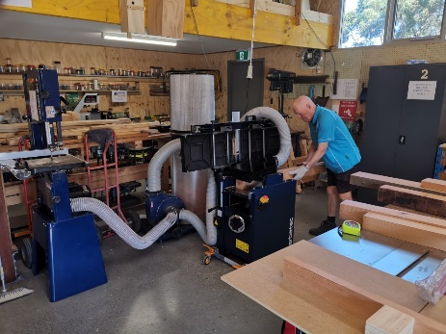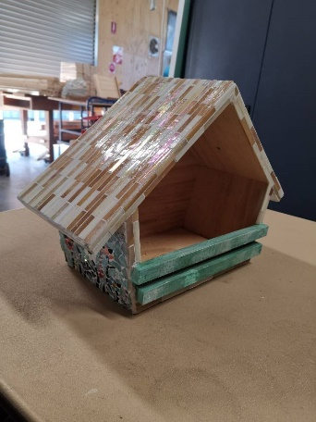The Shed has been open for three weeks since the Christmas break. Happy New Year to all of you and I hope that you enjoyed a great family time and they restocked your supply of socks and hankies. No New Year’s resolutions for me as I don’t want the stress of having to make good on them.

We have had a slow start to the year as far as attendance is concerned, most likely due to the hotter weather and some members being very cautious due to the pandemic. Regardless of this there have been several changes. Before I go into these I need to remind everybody to continue to follow our procedures to reduce the risk of catching Covid. This, firstly, requires everybody who enters our Shed to be double vaccinated. Having the booster on top of this is even better.

Storage

For sometime now we have complained about the not-so-convenient way we were using our shipping container to store our timber. This has now changed with our storage racks being moved forward to the front double doors with timber sheets and long lengths now being accessible without even stepping into the container. The heaviest material is now the easiest to access. This has left space at the rear to store small lengths, paint and various bits and pieces. This is now accessed by having cut a hole in the back righthand side and building in a personal access door. Early days, but we think this change is going to make our storage work well. Thanks for your work on this Tony and George. Whilst on the topic of storage, our use of the mezzanine space has meant that we have taken a lot of excess tools, equipment and supplies off the workshop floor, therefore improving our workshop space.

Projects

The year has started with the production of 9 wicking garden beds. We soon found out that timber has become more expensive. George has set up a process which has turned our work into more of a production line which has increased our efficiency, quality and speed. In the meantime Peter S has nearly completed the Kids Free Library for a politician’s office. We have also worked on two small projects for a couple of individuals who are establishing their own businesses. Also we are currently negotiating to do some work for the Royal Adelaide Golf Club.

Late last year we had the pleasure of helping Patrick Ikaringanyi Ferguson by doing some initial cuts on a couple of trophies he was making for the winners of the 2022 Adelaide International Tennis Tournament.

Equipment

Recently we were fortunate to get $3500 from an AMSA grant that I applied for earlier in 2021. This assisted us in purchasing a new SawStop table saw. This is a very good piece of precision equipment with some excellent safety features including the fact that the user is unable to sustain any serious injury. The committee had also decided to buy a combined planer/thicknesser. We now have this equipment and it has already proved its worth. Both machines will help us produce some quality projects.

Workshop Layout

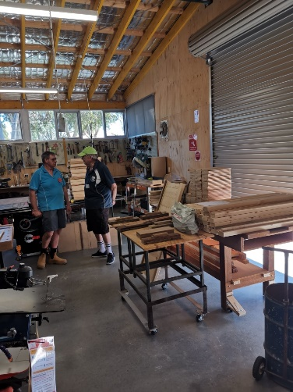With the placement of the new equipment is was decided this was a good time to redesign the workshop layout. Eventually all benches, equipment and cupboards will be on wheels so we can move things around to suit the projects we have at any one time. It also means that if a layout doesn’t work, we can easily move things around. This is an important feature in managing a workshop of our size. Please make sure we get your feedback so that we can continually improve. It is important that all members feel our Shed belongs to all of us.

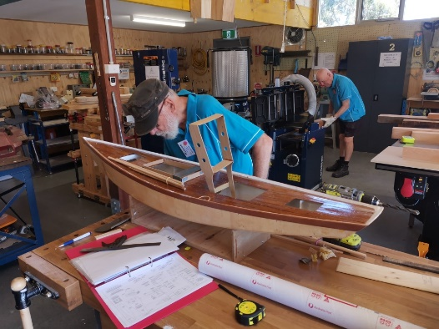Tyro

This week we received our Tyro EFTPOS machine thanks to Russell who persevered over several weeks during the application period. If you want to make payments through our machine just ask one of the supervisors. We are looking forward to this machine making our life at little easier when we run our Bunnings BBQs. Incidentally the dates of our BBQs are on a notice, on the kitchen area table, so how about putting at least one date in your diary.

Veranda

Yes, our verandah over the ramp has been approved and I have been informed it will be built sometime this month. Naturally with any building at the moment I will believe this when the installers arrive. We are certainly looking forward to this improvement to keep the morning sun off the door as well as providing us with some more undercover workspace.

Safety - Induction

One of the major considerations when running a Men’s Shed is safety. It is also one of those things that requires some specific actions to reduce risk of injury and to ensure that each member is properly covered by insurance if something happens. There are two things we are working on. Firstly each member should have a general workshop induction. For existing members I have produced a document which each member needs to read and understand and then inform a supervisor that they have done so and this will be recorded. General Workshop Induction completed!! For new members a supervisor will ‘walk’ them through this document as certain aspects of safety in the workshop are pointed out.

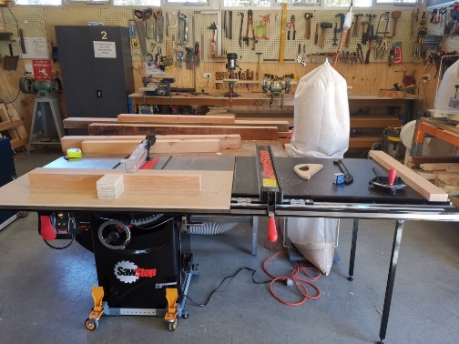Next, is equipment induction/training. Even though many members have used machinery for many years/decades it is still important to confirm the safe use of our equipment by our members.  All of our equipment which is classed as having medium, high or severe risk has a Safe Operating Procedure attached to it. There is a two stage process to be ‘ticked’ off for this equipment. Firstly, you need to read and understand the SOP and then ask a trainer to give you a session to ‘walk’ you through the safe use of that piece of equipment. This could take 5mins or a bit more for machinery such as the table saw and the thicknesser/planer. After this one-off training you will be signed off on your individual sheet to show you have had your induction.  You only need to do this with the machinery you want to use and generally just before you want to use it, no rush, please do this over a period of time as needed. Eventually every member will catch up with this.

A list of trainers will be on the pinup board in the kitchen area.

This will do for now. I hope you have enjoyed the read.

**Peter Rawlins**

*President/Workshop Coordinator*